CURRICULUM VITAE
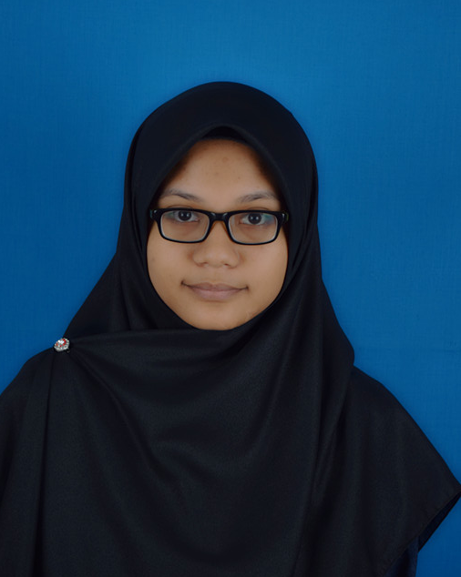
NAME : HIDAYATULMUNAWARAH BINTI KURBANI
ADDRESS : MALAYSIA JAPAN HIGHER EDUCATION
PROGRAMME(MJHEP), MARA JAPAN
INDUSTRIAL INSTITUTE, LOT 2333,
JALAN KAJANG SEREMBAN 43700,
BERANANG, SELANGOR.

PHONE NUMBER : 012 5474795
EMAIL : hidayatulmunawarah@gmail.com

1.0 PERSONAL PARTICULAR
NAME | HIDAYATULMUNAWARAH BINTI KURBANI
ADDRESS | NO 45, LORONG 4, TAMAN RIA MESRA 2,  08300, GURUN KEDAH
PLACE OF BIRTH | KUALA LUMPUR
DATE OF BIRTH | 09 DECEMBER 1997
NATIONALITY | MALAYSIAN
OBJECTIVE | - TO GAIN HANDS ON EXPERIENCE.  - TO IMPROVE SOCIAL SKILLS.  - TO GAIN MORE KNOWLEDGE THROUGH PRACTICAL.  - TO EXPERIENCE REAL SITUATIONS IN INDUSTRIAL ORGANIZATION.
AVAILABILITY | 2 MONTH (7th AUGUST 2017 – 29th SEPTEMBER 2017)
2.0 EDUCATIONAL BACKGROUND
EDUCATION
  INSTITUTION | LEVEL | DURATION
  MARA JAPAN HIGHER EDUCATION PROGRAMME (MJHEP), UNIKL IPROM | DIPLOMA OF ELECTRICAL ENGINEERING | 2015 - 2017
  MAKTAB RENDAH SAINS MARA MERBOK | SIJIL PELAJARAN MALAYSIA  (SPM) | 2010-2014
ACADEMIC ACHIEVEMENTS | - (2016) DEAN LIST AWARD  - CGPA 3.68  - (2015) 9A in SPM 2014
3.0 EXPERIENCES
PERSONAL STRENGTHS | .  - CAN DO MULTITASK.  - ABLE TO WORK WITH MINIMUM SUPERVISION.  - DETERMINE IN ORDER TO ACHIEVE A TARGET.
4.0 SKILLS
COMPUTER SKILLS | Microsoft Office (Word, PowerPoint and Excel), Visual Studio.
LANGUAGE SKILLS
  LANGUAGE | WRITING | SPOKEN
  BAHASA MELAYU | EXCELLENT | EXCELLENT
  ENGLISH | EXCELLENT | MODERATE
  JAPANESE | MODERATE | MODERATE
5.0 ACTIVITIES AND HONORS
HOBBIES & INTERESTS | - TRAVEL AND EXPERIENCE NEW THINGS  - PLAYING BADMINTON AND NETBALL.
REFERENCES
  NAME | PN HALIMAH BINTI AHMAD
  POSITION | HEAD of DEPARTMENT ELECTRICAL AND ELECTRONIC ENGINEERING, MARA JAPA HIGHER EDUCATION PROGRAMME, UNIKL IPROM.
  CONTACT NUMBER | 013 5000124
  EMAIL ADDRESS | halimah@jadypm.edu.my

